1.Create a new branch ‘js-assignments’.

2.Switch to ‘js-assignments’ branch.

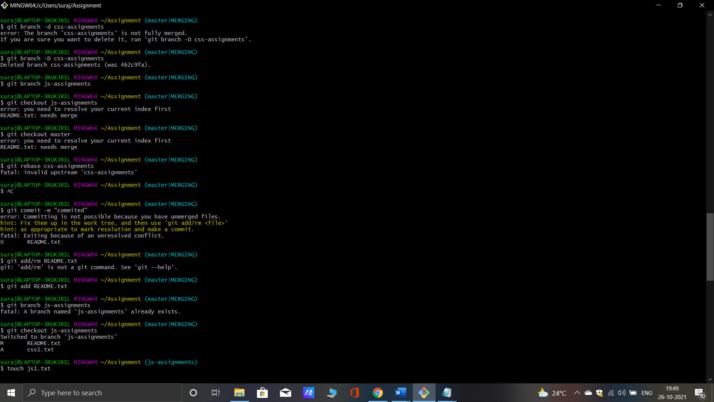

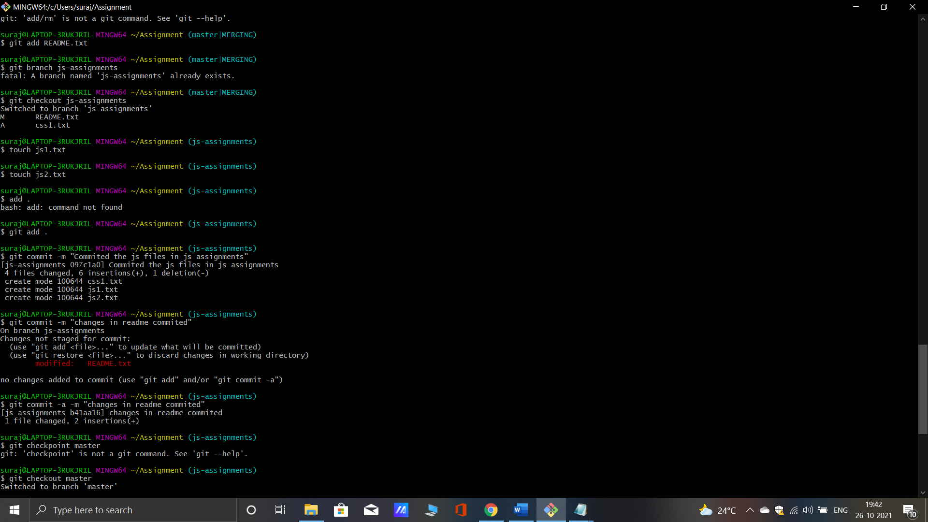

3. Copy all JavaScript assignments inside ‘Assignments’ folder.

4.Commit JavaScript assignments into ‘js-assignments’ branch.



5. Make minor changes into README.txt file on line 1 belonging to ‘js-assignments’ branch.

6.Commit those changed files.



7. Switch to master branch.

8.Make minor changes into README.txt file on line 1 & commit those changes into master.

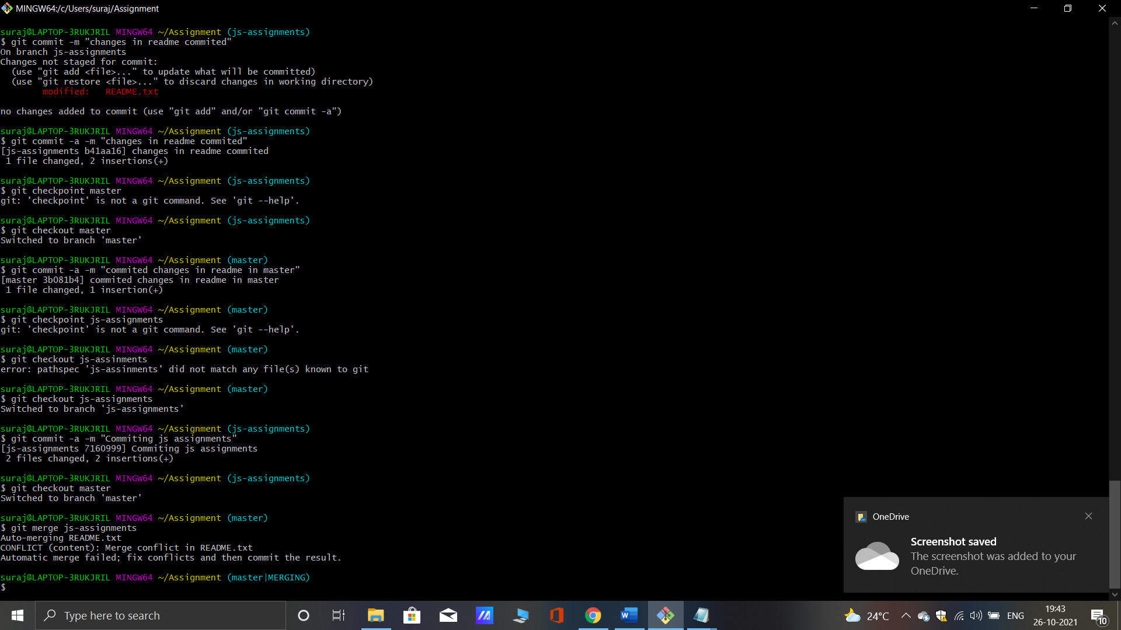

9. Again switch to ‘js-assignments’ branch.

10.Make minor changes into few files belonging to ‘js-assignments’ branch.

11.Commit those changes.



12. Switch to master.

13.Merge ‘js-assignments’ branch into master. Confirm all JavaScript assignments are shown in master.

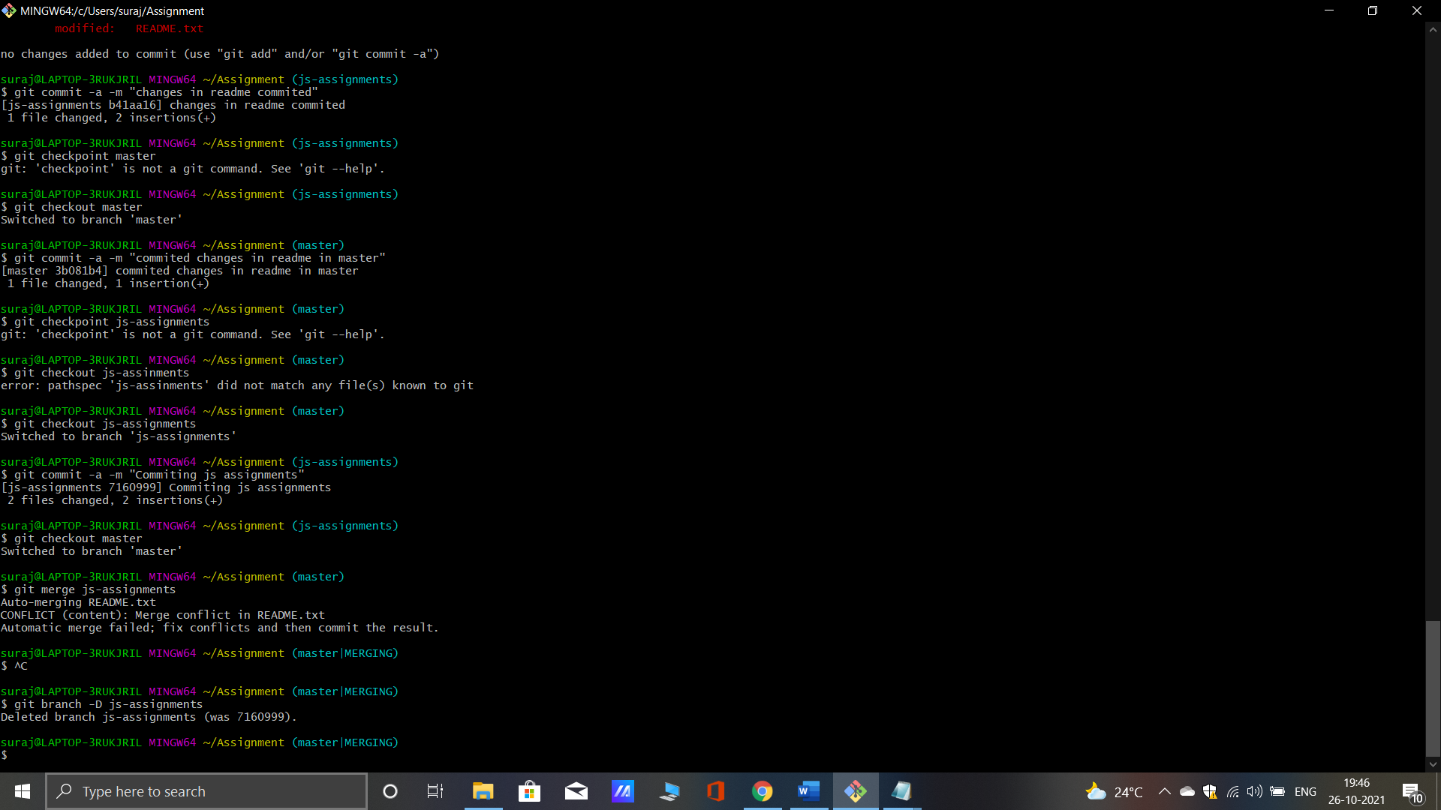

14. Finally delete the ‘js-assignments’ branch.

